Third Year Project Questions
The aim is to create an outstanding body of work demonstrating a very deep insight into the problem and to present it as such.
Introduction
What is the real world problem you are looking at?
Photographers often experience burn out, snap-challenges is a
fun and collaborative web app to combat this.

Why is it important?
One of the main ways to improve at photography is to just get out there in the field and practice. This app gives the user a reason to get out and do this practice. This will hopefully lead to an improvement in their photography which benefits the whole community as we get to see better photos. The app will also show camera settings which will help users understand the technique used to get the photo.

Are there any legal or ethical issues?
I will be handling and storing user data in a database. This will need to be kept secure and private. Although I do not have any plans to store passwords, instead I’ll use OAuth2 to allow users to sign in with pre-existing accounts on other services.

Research
What don’t I know that I need to find out? (Your research questions)
HTTP Protocol - REST API standard
Database choice - SQL vs NOSQL
Gamification – Advantages and Disadvantages,
Have people tried to gamify photography before?

How am I going to carry out a search for information?
UWE Library Search
Google Scholar

Peer Reviewed Journals,
Conference Papers,
Standards,
Source Code

What is the current state-of-the-art (technology and algorithms)?
Most apps have been written natively to support the devices they are intended to run on, this works, but requires multiple varying code bases for each platform, there are a few different solutions to this problem, The first is to create a Progressive Web App (PWA), this allows you to build one responsive website that works across all devices and gives the user the ability download it as an app. The downside of this is you do not get any native access to the device and have limited control of features such as the camera and notifications. PWAs also arent currently supported on the ios appstore, however they are on Google Play.

The second solution, which is the one that I will use is to create an app which can be deployed to multiple platforms from one code base, there are many tools which allow you to achieve this, I will be using React Native as it has widely been adopted and there is lots of information and modules available for use with it. Other alternatives would have been Electron or Flutter. Many popular apps have been built using this approach as it reduces the need to maintain 3 or 4 seperate codebases to just one. Examples of apps built with this technology are:

- Coinbase (React Native),
- Skype (React Native),
- Tesla (React Native),
- Slack(Electron),
- Discord(Electron),
- Vscode(Electron)
- Alibaba(Flutter)

How have other people tried to solve it (products)?
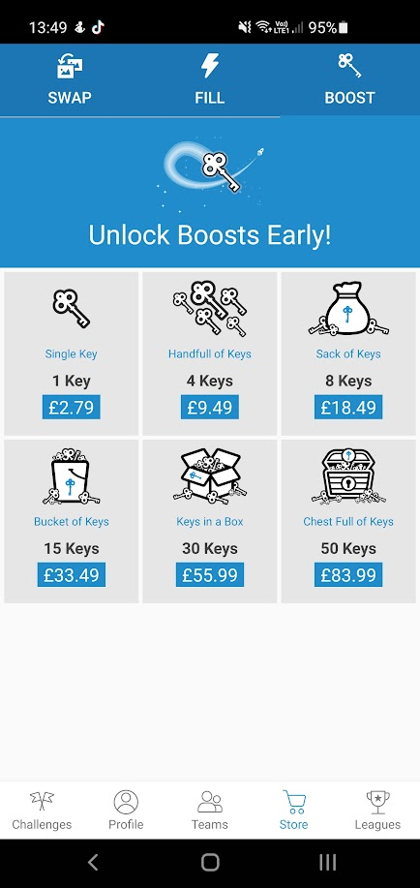

Yes, there is an existing app called GuruShots, however the app is of poor quality and feels like a cash grab, it is full of micro-purchases. Ontop of that there are also a lot of adverts an example can be seen in the image on the right.

The app also does show the image metadata however, it is not visible directly on the post and requires a few clicks to reach. This means it is not directly visible to the average person just scrolling and therefore likely gets ignored by most users. This information will be much more prominent in snap-challenges to ensure people can learn from others work.

What am I claiming about this project? (Claim/Hypothesis/Assertion)

What are my project goals and objectives?

What will be my success criteria?

Requirements
Describe the context of the system

What is the scope of the system (what will it do and what will it not do)?

How were the requirements identified?

Did you gather any requirements from potential users (or others) and if yes, how?

What requirements were found during research?

How are your requirements going to be formally expressed (list, use case model, etc)?

How will you prioritise your requirements?

Note: The reason for each requirement will need to be explained.
Here’s where you might list your requirements....

How will the requirements be tested (functional and non-functional)?

Do you have test data?

Do the requirements break down to produce sub-projects, if so how?

Methodology
What methodology will be used during your development?

Design
What alternative designs have you considered?

Why have you chosen the design that you have?

How have you identified the different components of your design?

How are you going to describe your design?

What issues arose during the design process?

What test data did you specify?

Implementation
How will you implement your project and why?

How will you record how you implemented it?

What issues arose during implementation?

How will you demonstrate that it works?

How will you show what has been achieved?

Has anything not been finished?

Testing (party of Implementation)
How will you test your code?

How do your tests prove that your code works correctly?

How will you document your test results?

Evaluation
Do your findings support or refute your claim?

Have you met your original project goals?

What limitations does your product have?

What thoughts do you have now about your product?

Conclusion
How could you improve your product?

How could you improve the development process?

What would you do differently?

